PHYSICAL DATA ORGANIZATION
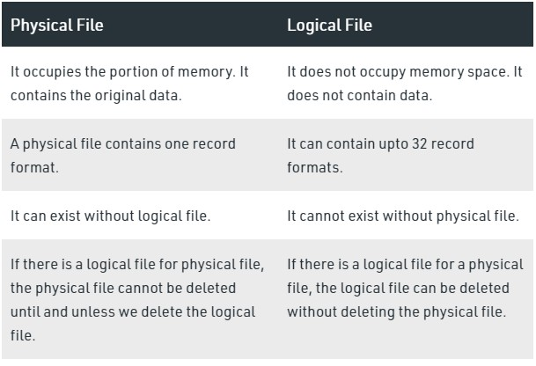

File organizations
File organization refers to the organization of the data of a file into records, blocks, and access structures; this includes the way records and blocks are placed on the storage medium and interlinked. An access method, on the other hand, provides a group of operations that can be applied to a file. In general, it is possible to apply several access methods to a file organization

Primary file organizations
Primary file organizations determines how the file records are physically placed on the disk, and hence how the records can be accessed.
- Heap file (or unordered file) places the records on disk in no particular order by appending new records at the end of the file
- Sorted file (or sequential file) keeps the records ordered by the value of a particular field (called the sort key).
- Hashed file uses a hash function applied to a particular field (called the hash key) to determine a record’s placement on disk.
- Other primary file organizations, such as B-trees, use tree structures

Secondary organization
A secondary organization or auxiliary access structure allows efficient access to file records based on alternate fields than those that have been used for the primary file organization.

Spanned and Unspanned Organization
A block is the unit of data transfer between disk and memory. When the block size is larger than the record size, each block will contain numerous records, although some files may have unusually large records that cannot fit in one block.
Part of the record can be stored on one block and the rest on another. A pointer at the end of the first block points to the block containing the remainder of the record. This organization is called spanned because records can span more than one block. Whenever a record is larger than a block, we must use a spanned organization. If records are not allowed to cross block boundaries, the organization is called unspanned.
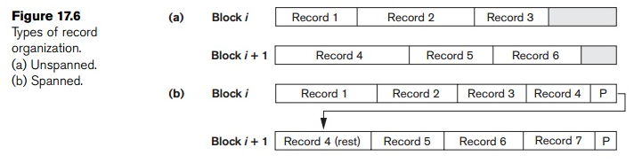

Blocking factor for the file
The records of a file must be allocated to disk blocks because a block is the unit of data transfer between disk and memory. When the block size is larger than the record size, each block will contain numerous records, although some files may have unusually large records that cannot fit in one block. Suppose that the block size is B bytes. For a file of fixed-length records of size R bytes, with B ≥ R, we can fit bfr =└ B / R┘ records per block. The value bfr is called the blocking factor for the file.
In general, R may not divide B exactly, so we have some unused space in each block equal to
B − (bfr * R) bytes.
To utilize this unused space, we can store part of a record on one block and the rest on another. A pointer at the end of the first block points to the block containing the remainder of the record in case it is not the next consecutive block on disk. This organization is called spanned because records can span more than one block. Whenever a record is larger than a block, we must use a spanned organization. If records are not allowed to cross block boundaries, the organization is called unspanned. If the average record is large, it is advantageous to use spanning to reduce the lost space in each block.
For variable-length records using spanned organization, each block may store a different number of records. In this case, the blocking factor bfr represents the average number of records per block for the file. We can use bfr to calculate the number of blocks b needed for a file of r records:
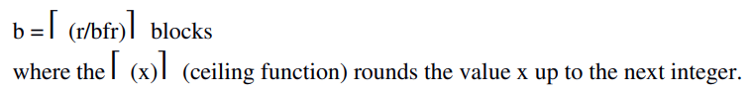

- A file is a sequence of records.
- In many cases, all records in a file are of the same record type.
- If every record in the file has exactly the same size (in bytes), the file is said to be made up of fixed-length records.
- If different records in the file have different sizes, the file is said to be made up of variable-length records.
Part of the record can be stored on one block and the rest on another. A pointer at the end of the first block points to the block containing the remainder of the record. This organization is called spanned because records can span more than one block. Whenever a record is larger than a block, we must use a spanned organization. If records are not allowed to cross block boundaries, the organization is called unspanned.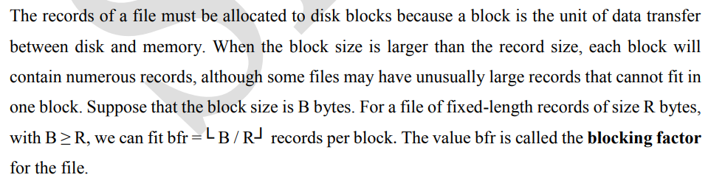
Files of Unordered Records
Records are placed in the file in the order in which they are inserted, so new records are inserted at the end of the file. Such an organization is called a heap or pile file. Inserting a new record is very efficient. The last disk block of the file is copied into a buffer, the new record is added, and the block is then rewritten back to disk. The address of the last file block is kept in the file header. However, searching for a record using any search condition involves a linear search through the file block by block—an expensive procedure. To delete a record, a program must first find its block, copy the block into a buffer, delete the record from the buffer, and finally rewrite the block back to the disk. This leaves unused space in the disk block.
Index Structures
Indexing is a technique for improving database performance by reducing the number of disk accesses necessary when a query is run.
Indexing is a data structure technique to efficiently retrieve records from the database files based on some attributes on which the indexing has been done. An index on a database table provides a convenient mechanism for locating a row (data record) without scanning the entire table and thus greatly reduces the time it takes to process a query. The index is usually specified on one field of the file. One form of an index is a file of entries <field value, pointer to record>, which is ordered by field value. The index file usually occupies considerably less disk blocks than the data file because its entries are much smaller.
- Indexes can be characterized as dense or sparse.
- A dense index has an index entry for every search key value (and hence every record) in the data file.
- A sparse (or nondense) index, on the other hand, has index entries for only some of the search values.
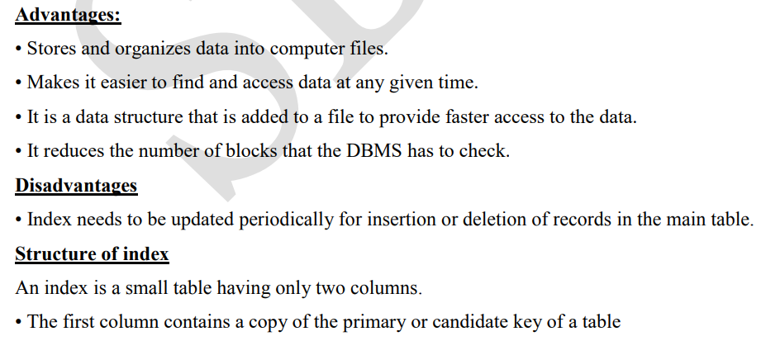
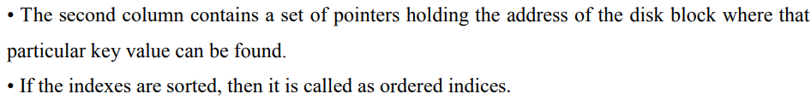
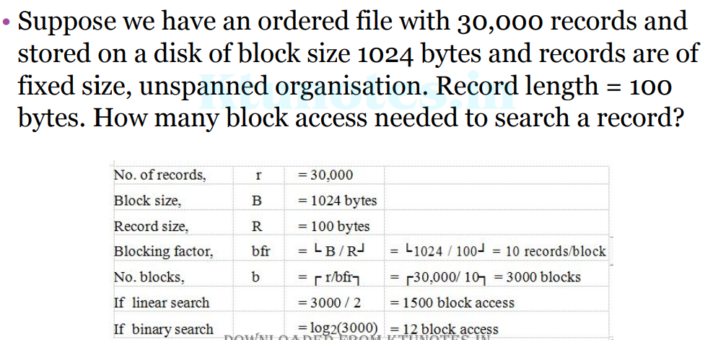
Types of Single-Level Indexes
Primary Index
• Primary index is defined on an ordered data file. The data file is ordered on a key field.
• The key field is generally the primary key of the relation.
- Includes one index entry for each block in the data file; the index entry has the key field value for the first record in the block, which is called the block anchor.
- A similar scheme can use the last record in a block.
- A primary index is a nondense (sparse) index, since it includes an entry for each disk block of the data file and the keys of its anchor record rather than for every search value.
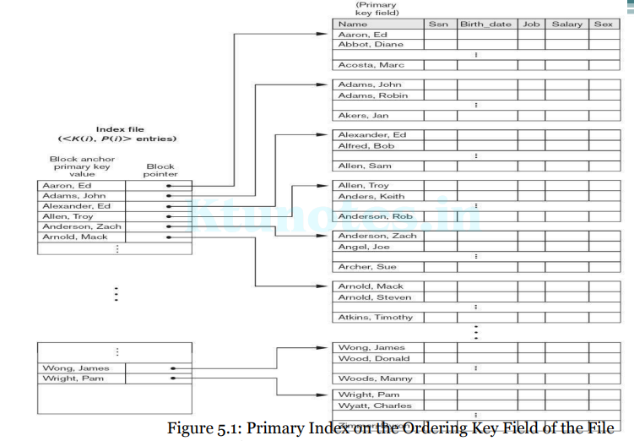
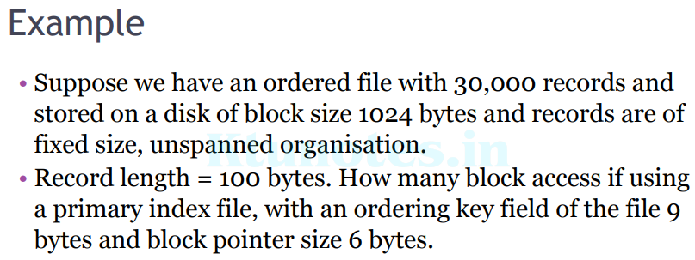
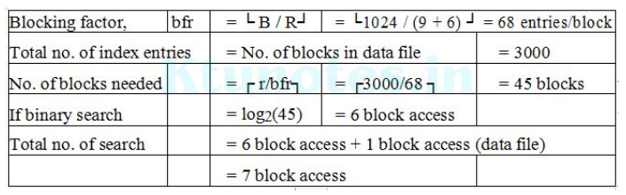
Clustering Index
- Defined on an ordered data file
- The data file is ordered on a non-key field unlike primary index, which requires that the ordering field of the data file have a distinct value for each record.
- Includes one index entry for each distinct value of the field; the index entry points to the first data block that contains records with that field value.
- It is another example of nondense index where Insertion and Deletion is relatively straightforward with a clustering index.
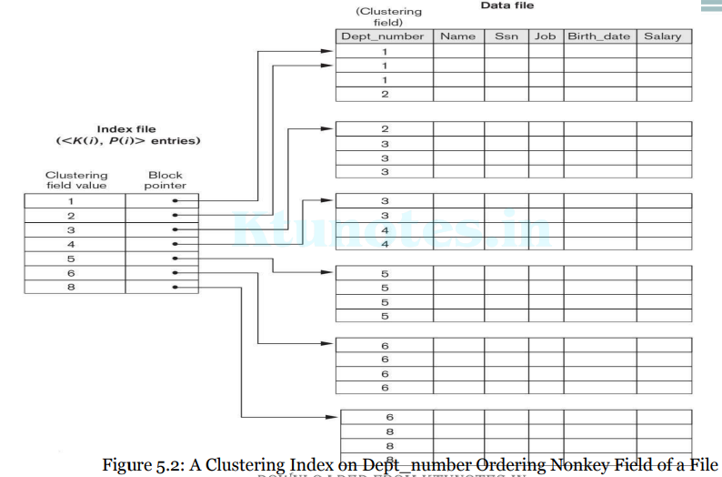
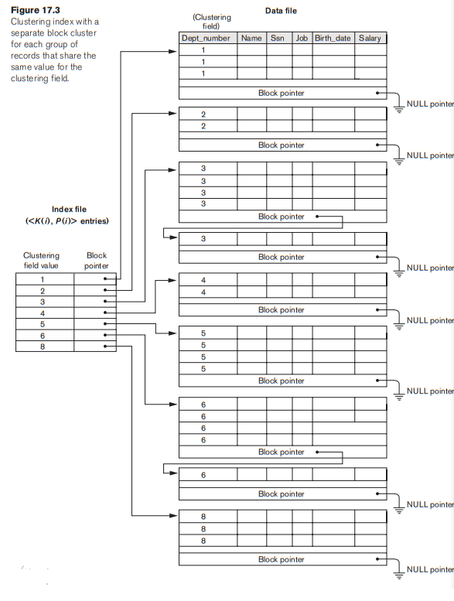

Secondary Index
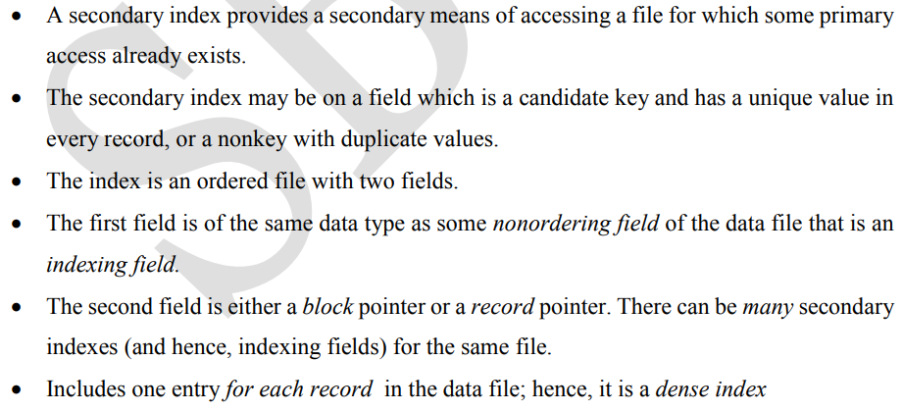
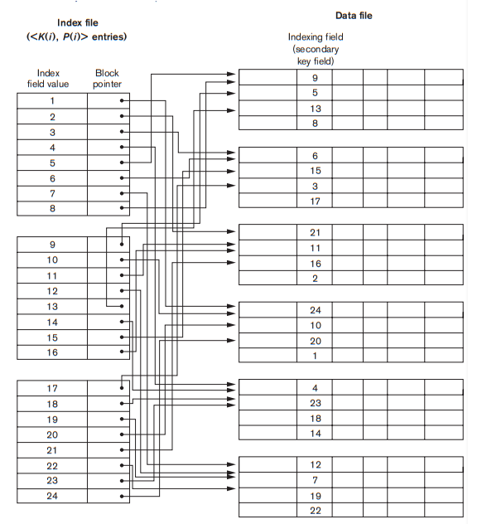
Figure 5.4: A dense secondary index (with block pointers) on a nonordering key field of a file
Figure 5.5: A secondary index (with record pointers) on a nonkey field implemented using one level of indirection so that index entries are of fixed length and have unique field values.
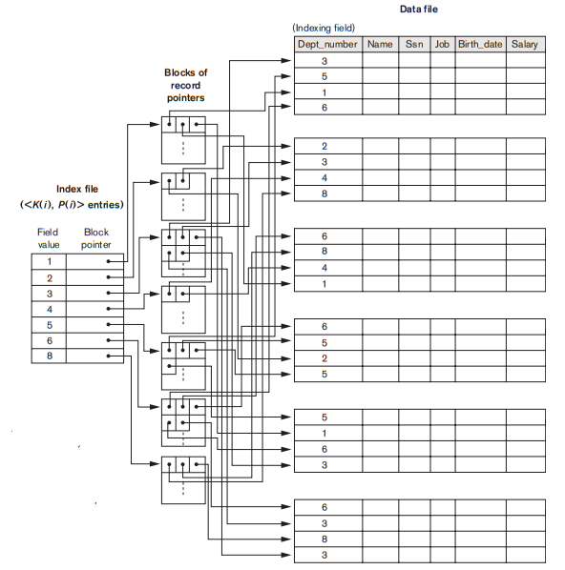
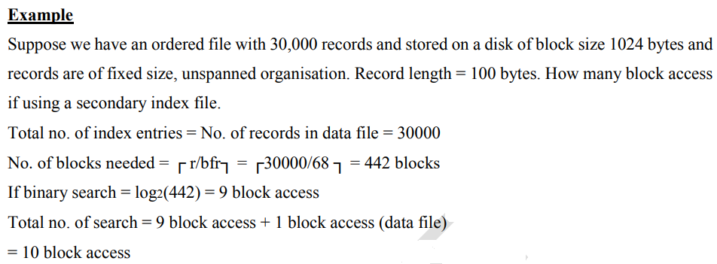
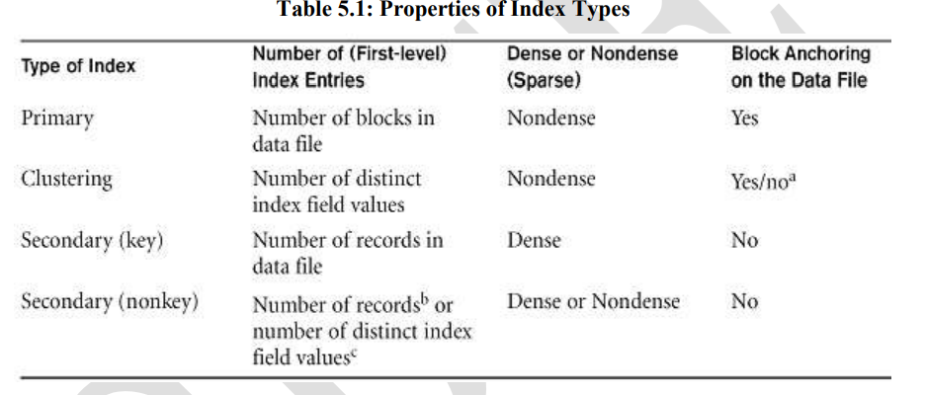
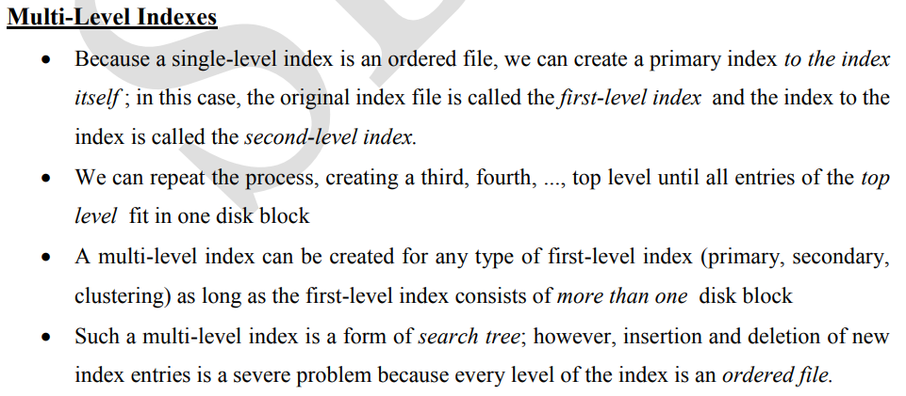
A common file organization used in business data processing is an ordered file with a multilevel primary index on its ordering key field. Such an organization is called an indexed sequential file and was used in a large number of early IBM systems. IBM’s ISAM organization incorporates a two-level index that is closely related to the organization of the disk in terms of cylinders and tracks.
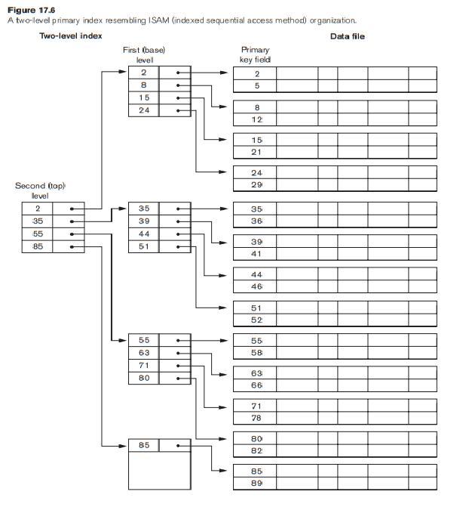
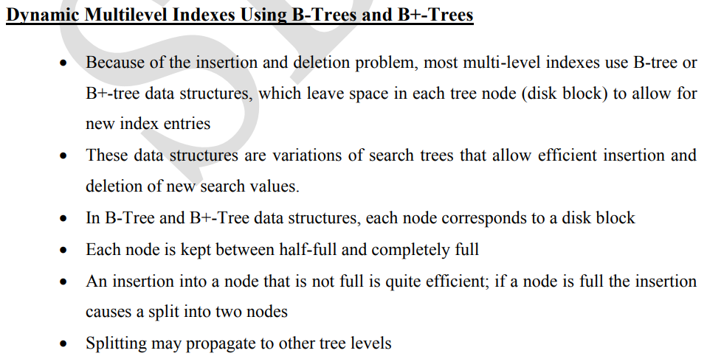
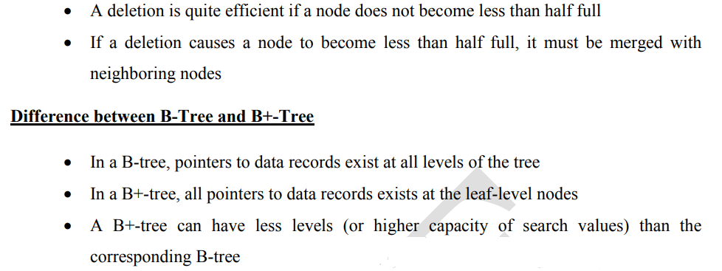
- In B+trees, search keys can be repeated but this is not the case for B-trees.
- B+trees allow satellite data to be stored in leaf nodes only, whereas B-trees store data in both leaf and internal nodes.
- In B+trees, data stored on the leaf node makes the search more efficient since we can store more keys in internal nodes.
▫ this means we need to access fewer nodes.
- Deleting data from a B+tree is easier and less time consuming because we only need to remove data from leaf nodes.
- Leaf nodes in a B+tree are linked together making range search operations efficient and quick.
- Finally, although B-trees are useful, B+trees are more popular. In fact, 99% of database management systems use B+trees for indexing.
- This is because the B+tree holds no data in the internal nodes.
- This maximizes the number of keys stored in a node thereby minimizing the number of levels needed in a tree.
- Smaller tree depth invariably means faster search.
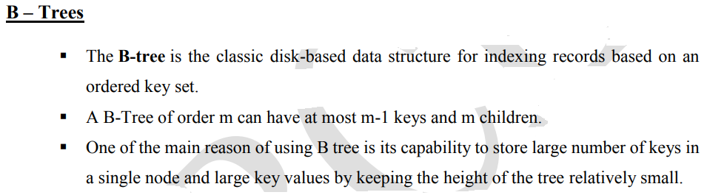
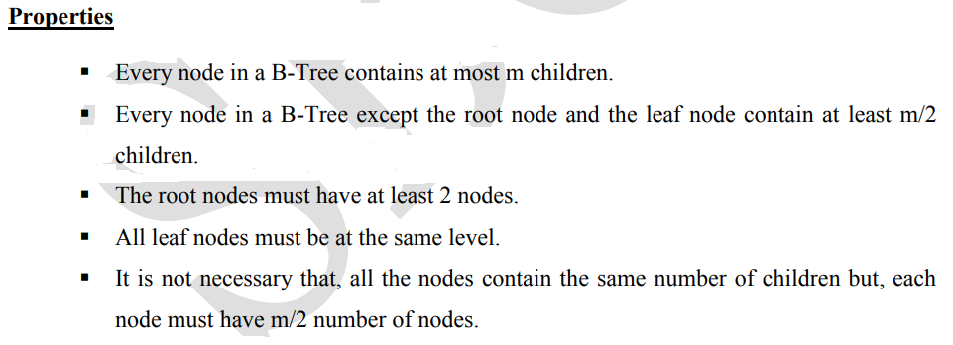
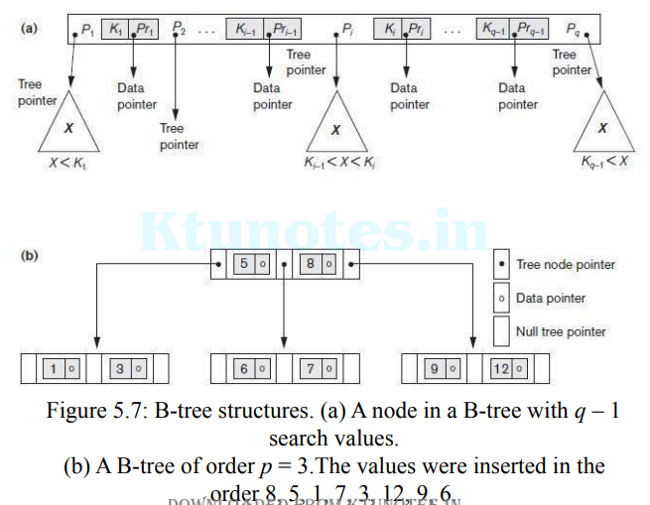
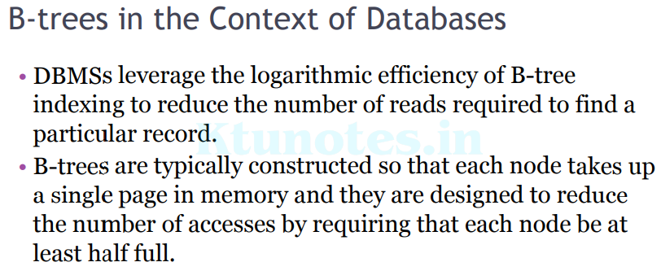
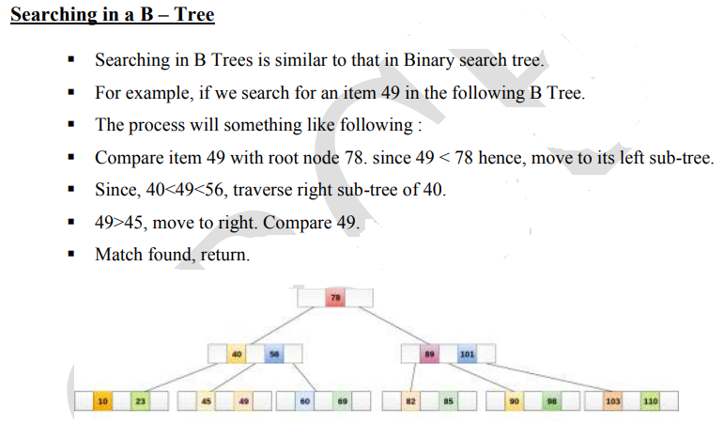
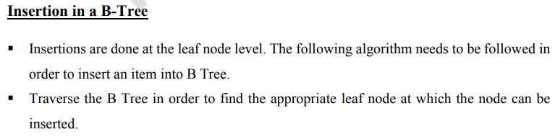
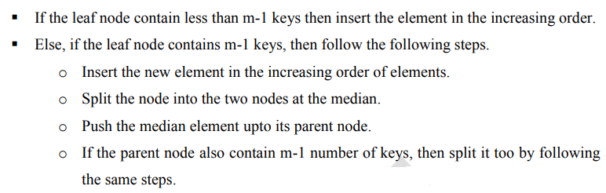
The elements to be inserted are 8, 9, 10, 11, 15, 20, 17.
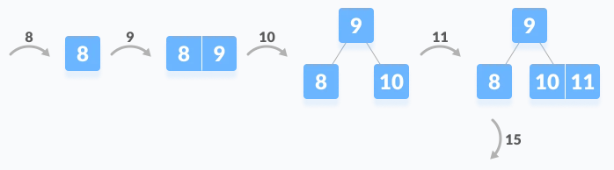
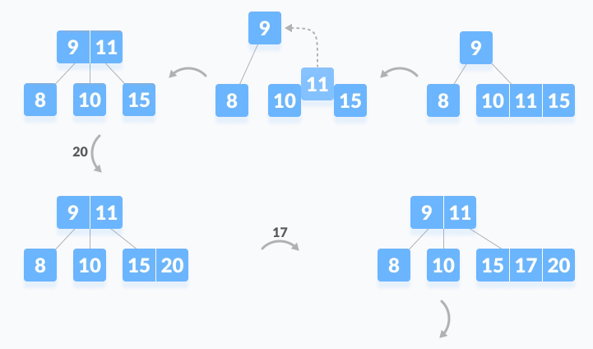
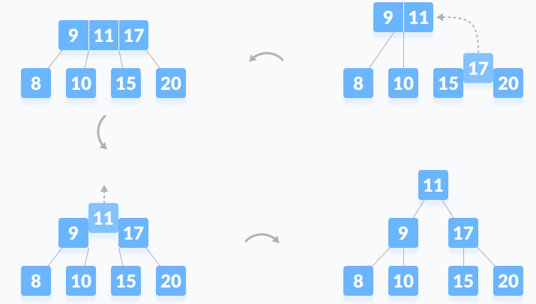

Deletion from a B-Tree
Deleting an element on a B-tree consists of three main events: searching the node where the key to be deleted exists, deleting the key and balancing the tree if required. While deleting a tree, a condition called underflow may occur. Underflow occurs when a node contains less than the minimum number of keys it should hold.
The terms to be understood before studying deletion operation are:
- Inorder Predecessor
The largest key on the left child of a node is called its inorder predecessor.
- Inorder Successor
The smallest key on the right child of a node is called its inorder successor.

Deletion Operation
Before going through the steps below, one must know these facts about a B tree of degree m.
- A node can have a maximum of m children. (i.e. 3)
- A node can contain a maximum of m - 1 keys. (i.e. 2)
- A node should have a minimum of ⌈m/2⌉ children. (i.e. 2)
- A node (except root node) should contain a minimum of ⌈m/2⌉ - 1 keys. (i.e. 1)
There are three main cases for deletion operation in a B tree.

Case I
The key to be deleted lies in the leaf. There are two cases for it.
- The deletion of the key does not violate the property of the minimum number of keys a node should hold.
In the tree below, deleting 32 does not violate the above properties.
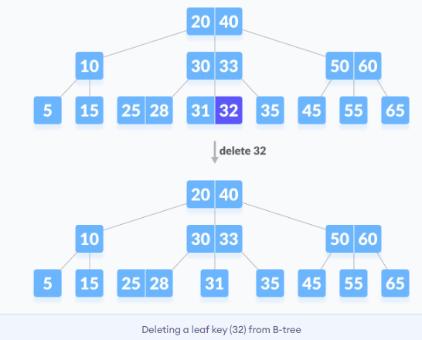
- The deletion of the key violates the property of the minimum number of keys a node should hold. In this case, we borrow a key from its immediate neighboring sibling node in the order of left to right.
First, visit the immediate left sibling. If the left sibling node has more than a minimum number of keys, then borrow a key from this node.
Else, check to borrow from the immediate right sibling node.
In the tree below, deleting 31 results in the above condition. Let us borrow a key from the left sibling node.
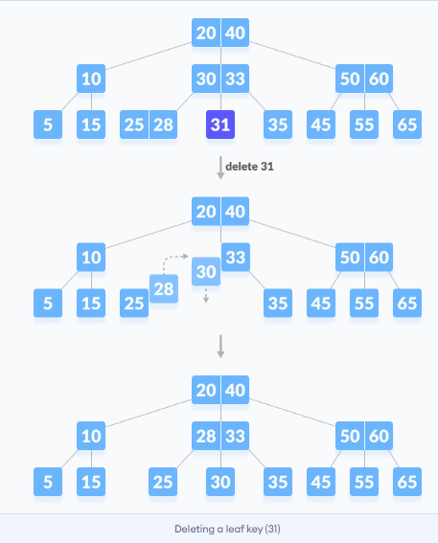
If both the immediate sibling nodes already have a minimum number of keys, then merge the node with either the left sibling node or the right sibling node. This merging is done through the parent node.
Deleting 30 results in the above case.
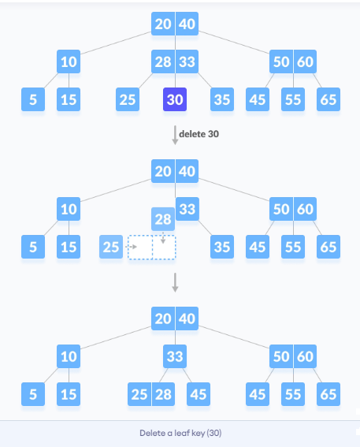

Case II
If the key to be deleted lies in the internal node, the following cases occur.
- The internal node, which is deleted, is replaced by an inorder predecessor if the left child has more than the minimum number of keys.
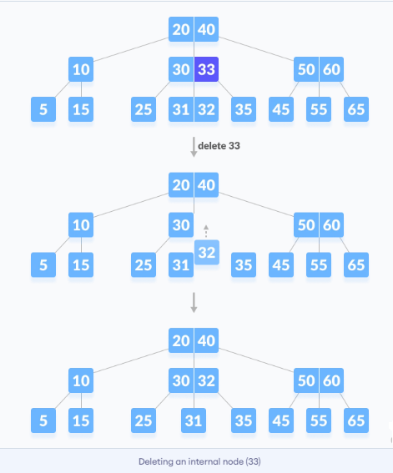
- The internal node, which is deleted, is replaced by an inorder successor if the right child has more than the minimum number of keys.
- If either child has exactly a minimum number of keys then, merge the left and the right children.
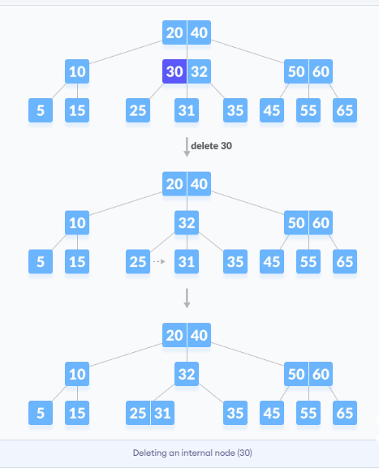
After merging if the parent node has less than the minimum number of keys then, look for the siblings as in Case I.

Case III
In this case, the height of the tree shrinks. If the target key lies in an internal node, and the deletion of the key leads to a fewer number of keys in the node (i.e. less than the minimum required), then look for the inorder predecessor and the inorder successor. If both the children contain a minimum number of keys then, borrowing cannot take place. This leads to Case II(3) i.e. merging the children.
Again, look for the sibling to borrow a key. But, if the sibling also has only a minimum number of keys then, merge the node with the sibling along with the parent. Arrange the children accordingly (increasing order).
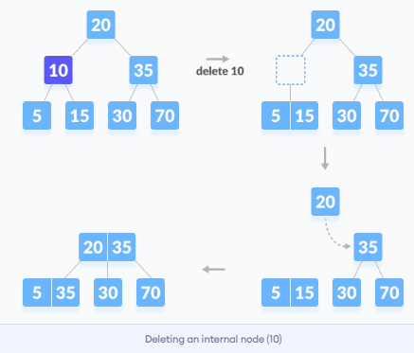

B+ Trees
- A B+ tree is an advanced form of a self-balancing tree .
- The B+ -tree is a variant of the original B-tree in which all records are stored in the leaves and all leaves are linked sequentially. The B+-tree is used as a (dynamic) indexing method in relational database management systems.
- All keys are duplicated in the leaves.
- An important concept to be understood before learning B+ tree is multilevel indexing. In multilevel indexing, the index of indices is created as in figure below. It makes accessing the data easier and faster.

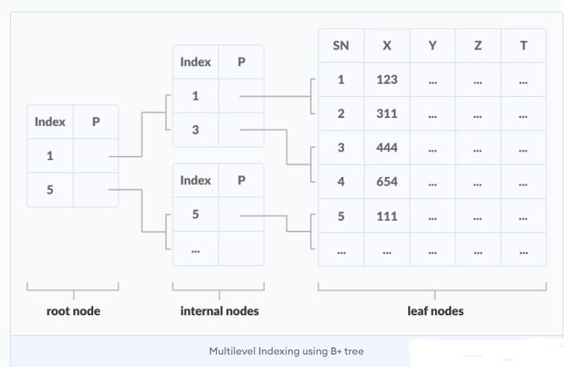
B+-Tree Structure

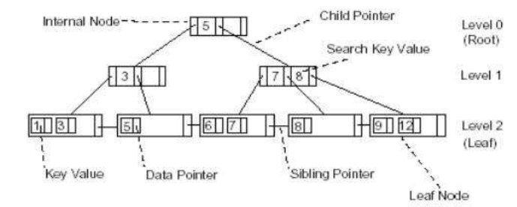

- A B + Tree consists of one or more blocks of data, called nodes, linked together by pointers. The B + -Tree is a tree structure. The tree has a single node at the top, called the root node. The root node points to two or more blocks , called child nodes. Each child nodes points to further child nodes and so on.

- The B + -Tree consists of two types of (1) internal nodes and (2) leaf nodes:
- Internal nodes point to other nodes in the tree.
- Leaf nodes point to data in the database using data pointers. Leaf nodes also contain an additional pointer, called the sibling pointer, which is used to improve the efficiency of certain types of search.
- All the nodes in a B + -Tree must be at least half full except the root node which may contain a minimum of two entries. The algorithms that allow data to be inserted into and deleted from a B + -Tree guarantee that each node in the tree will be at least half full.
- Searching for a value in the B + -Tree always starts at the root node and moves downwards until it reaches a leaf node.
- Both internal and leaf nodes contain key values that are used to guide the search for entries in the index.
- The B + -Tree is called a balanced tree because every path from the root node to a leaf node is the same length. A balanced tree means that all searches for individual values require the same number of nodes to be read from the disc.

Properties of a B+ Tree
- All leaves are at the same level.
- The root has at least two children.
- Each node except root can have a maximum of m children and at least m/2 children.
- Each node can contain a maximum of m - 1 keys and a minimum of ⌈m/2⌉ - 1 keys.

Comparison between a B-tree and a B+ Tree
- The data pointers are present only at the leaf nodes on a B+ tree whereas the data pointers are present in the internal, leaf or root nodes on a B-tree.
- The leaves are not connected with each other on a B-tree whereas they are connected on a B+ tree.
- Operations on a B+ tree are faster than on a B-tree.

Searching on a B+ Tree
Searching a B+-Tree for a key value always starts at the root node and descends down the tree. A search for a single key value in a B+-Tree consisting of unique values will always follow one path from the root node to a leaf node.
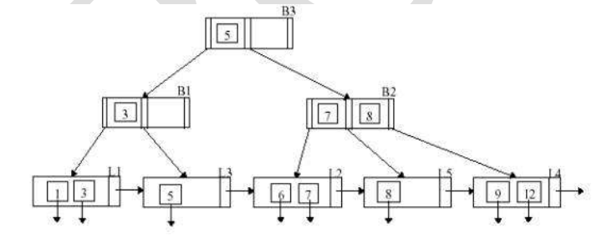
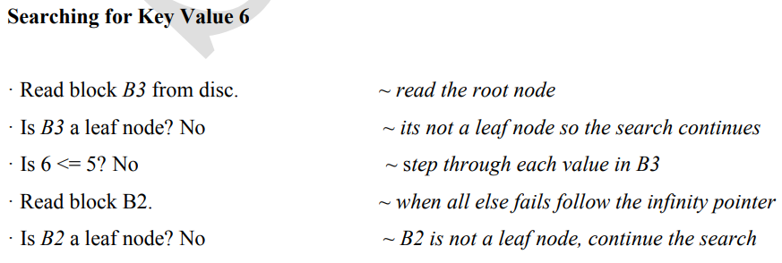
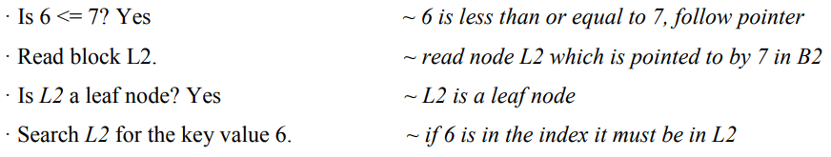
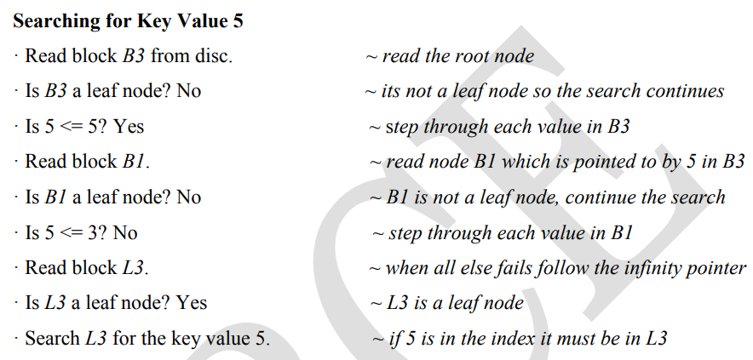

Inserting in a B+-Tree

During insertion following properties of B+ Tree must be followed:
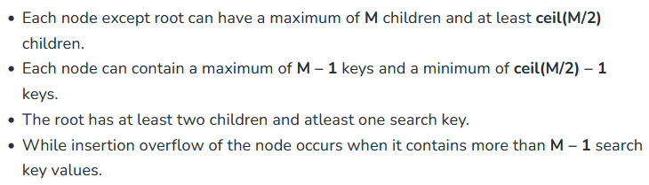
Here M is the order of B+ tree.

Steps for insertion in B+ Tree
- Every element is inserted into a leaf node. So, go to the appropriate leaf node.
- Insert the key into the leaf node in increasing order only if there is no overflow. If there is an overflow go ahead with the following steps mentioned below to deal with overflow while maintaining the B+ Tree properties.

Properties for insertion B+ Tree
Case 1: Overflow in leaf node
- Split the leaf node into two nodes.
- First node contains ceil((m-1)/2) values.
- Second node contains the remaining values.
- Copy the smallest search key value from second node to the parent node.(Right biased)
Below is the illustration of inserting 8 into B+ Tree of order of 5:
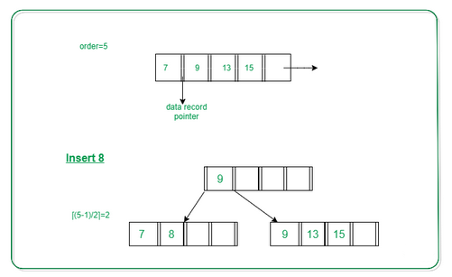
Case 2: Overflow in non-leaf node
- Split the non leaf node into two nodes.
- First node contains ceil(m/2)-1 values.
- Move the smallest among remaining to the parent.
- Second node contains the remaining keys.
Below is the illustration of inserting 15 into B+ Tree of order of 5:
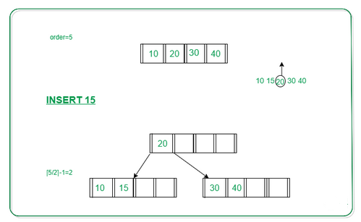
Problem: Insert the following key values 6, 16, 26, 36, 46 on a B+ tree with order = 3.
Step 1: The order is 3 so at maximum in a node so there can be only 2 search key values. As insertion happens on a leaf node only in a B+ tree so insert search key value 6 and 16 in increasing order in the node. Below is the illustration of the same:
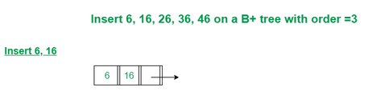
Step 2: We cannot insert 26 in the same node as it causes an overflow in the leaf node, We have to split the leaf node according to the rules. First part contains ceil((3-1)/2) values i.e., only 6. The second node contains the remaining values i.e., 16 and 26. Then also copy the smallest search key value from the second node to the parent node i.e., 16 to the parent node. Below is the illustration of the same:
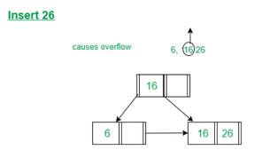
Step 3: Now the next value is 36 that is to be inserted after 26 but in that node, it causes an overflow again in that leaf node. Again follow the above steps to split the node. First part contains ceil((3-1)/2) values i.e., only 16. The second node contains the remaining values i.e., 26 and 36. Then also copy the smallest search key value from the second node to the parent node i.e., 26 to the parent node. Below is the illustration of the same:
The illustration is shown in the diagram below.
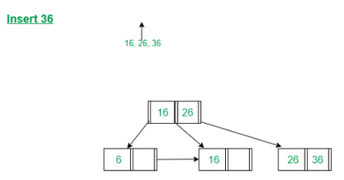
Step 4: Now we have to insert 46 which is to be inserted after 36 but it causes an overflow in the leaf node. So we split the node according to the rules. The first part contains 26 and the second part contains 36 and 46 but now we also have to copy 36 to the parent node but it causes overflow as only two search key values can be accommodated in a node. Now follow the steps to deal with overflow in the non-leaf node. First node contains ceil(3/2)-1 values i.e. ’16’. Move the smallest among remaining to the parent i.e ’26’ will be the new parent node.
The second node contains the remaining keys i.e ’36’ and the rest of the leaf nodes remain the same. Below is the illustration of the same:
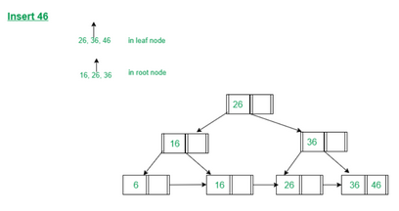
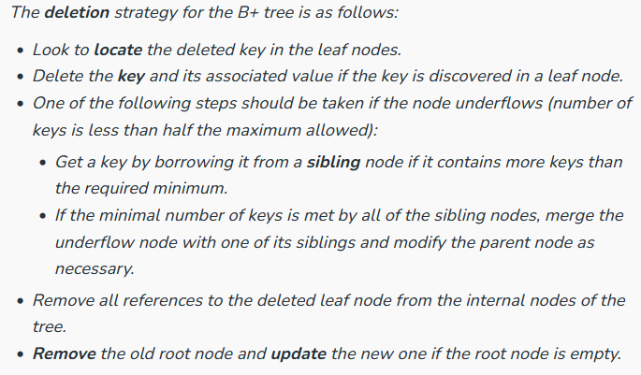
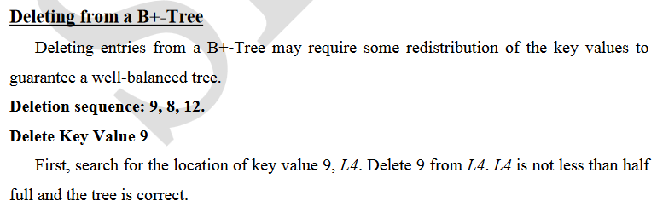
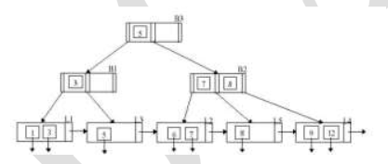
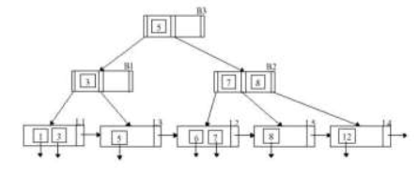
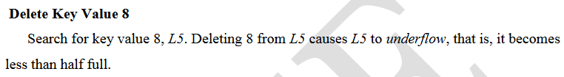
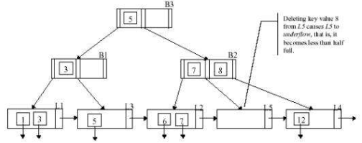
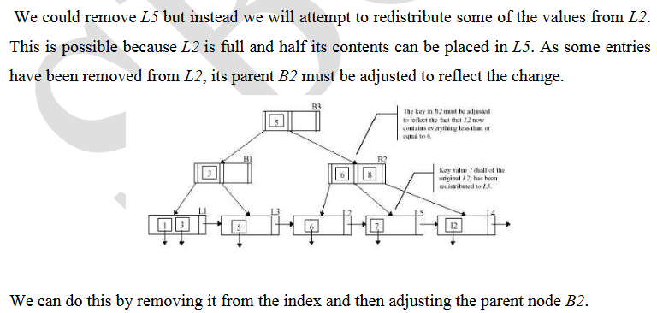
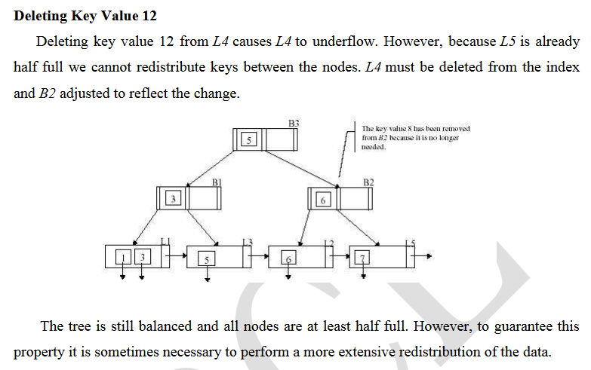
Extendible Hashing
- It is a dynamic hashing method wherein directories, and buckets are used to hash data..
- The terms in this hashing techniques are:
- Directories- The directories store addresses of the buckets in pointers. An id is assigned to each directory which may change each time when Directory expansion takes place.
- Number of Directories = 2^Global Depth.
- Buckets- The buckets are used to store the actual data.
- Global Depth- It is associated with the Directories. They denote the number of bits which are used by the hash function to categorize the keys.
- Global depth= number of bits in directory id.
- Local Depth: It is the same as that of Global Depth except for the fact that Local Depth is associated with the buckets and not the directories. Local depth in accordance with the global depth is used to decide the action that to be performed in case an overflow occurs. Local Depth is always less than or equal to the Global Depth.
- Bucket Splitting: When the number of elements in a bucket exceeds a particular size, then the bucket is split into two parts.
- Directory Expansion: Directory Expansion takes place when a bucket overflows. Directory Expansion is performed when the local depth of the overflowing bucket is equal to the global depth.
Basic Structure of Extendible Hashing:
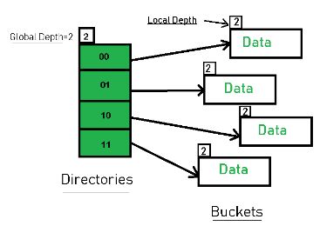

Basic Working of Extendible Hashing:

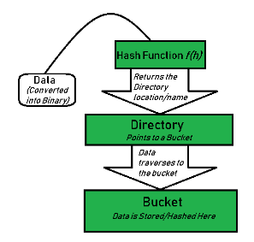

- Step 1 – Analyze Data Elements: Data elements may exist in various forms eg. Integer, String, Float, etc.. Currently, let us consider data elements of type integer. eg: 49.
- Step 2 – Convert into binary format: Convert the data element in Binary form. For string elements, consider the ASCII equivalent integer of the starting character and then convert the integer into binary form. Since we have 49 as our data element, its binary form is 110001.
- Step 3 – Check Global Depth of the directory. Suppose the global depth of the Hash-directory is 3.
- Step 4 – Identify the Directory: Consider the ‘Global-Depth’ number of LSBs in the binary number and match it to the directory id.
Eg. The binary obtained is: 110001 and the global-depth is 3. So, the hash function will return 3 LSBs of 110001 viz. 001.
- Step 5 – Navigation: Now, navigate to the bucket pointed by the directory with directory-id 001.
- Step 6 – Insertion and Overflow Check: Insert the element and check if the bucket overflows. If an overflow is encountered, go to step 7 followed by Step 8, otherwise, go to step 9.
- Step 7 – Tackling Over Flow Condition during Data Insertion: Many times, while inserting data in the buckets, it might happen that the Bucket overflows. In such cases, we need to follow an appropriate procedure to avoid mishandling of data.
First, Check if the local depth is less than or equal to the global depth. Then choose one of the cases below.
  - Case1: If the local depth of the overflowing Bucket is equal to the global depth, then Directory Expansion, as well as Bucket Split, needs to be performed. Then increment the global depth and the local depth value by 1. And, assign appropriate pointers.
Directory expansion will double the number of directories present in the hash structure.
  - Case2: In case the local depth is less than the global depth, then only Bucket Split takes place. Then increment only the local depth value by 1. And, assign appropriate pointers.
- Step 8 – Rehashing of Split Bucket Elements: The Elements present in the overflowing bucket that is split are rehashed w.r.t the new global depth of the directory.
- Step 9 – The element is successfully hashed.
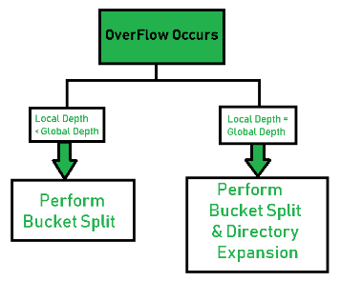
Example based on Extendible Hashing: Now, let us consider a prominent example of hashing the following elements: 16,4,6,22,24,10,31,7,9,20,26.
Bucket Size: 3 (Assume)
Hash Function: Suppose the global depth is X. Then the Hash Function returns X LSBs.
- Solution: First, calculate the binary forms of each of the given numbers.
16- 10000
4- 00100
6- 00110
22- 10110
24- 11000
10- 01010
31- 11111
7- 00111
9- 01001
20- 10100
26- 11010
- Initially, the global-depth and local-depth is always 1. Thus, the hashing frame looks like this:
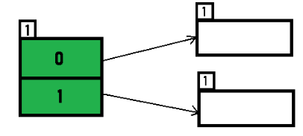
- Inserting 16:
The binary format of 16 is 10000 and global-depth is 1. The hash function returns 1 LSB of 10000 which is 0. Hence, 16 is mapped to the directory with id=0.
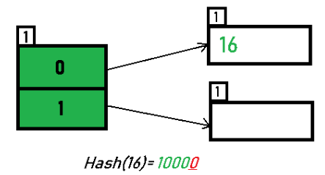
- Inserting 4 and 6:
Both 4(100) and 6(110)have 0 in their LSB. Hence, they are hashed as follows:
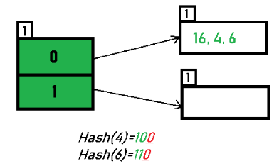
Inserting 22: The binary form of 22 is 10110. Its LSB is 0. The bucket pointed by directory 0 is already full. Hence, Over Flow occurs.
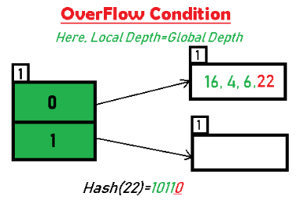
As directed by Step 7-Case 1, Since Local Depth = Global Depth, the bucket splits and directory expansion takes place. Also, rehashing of numbers present in the overflowing bucket takes place after the split. And, since the global depth is incremented by 1, now,the global depth is 2. Hence, 16,4,6,22 are now rehashed w.r.t 2 LSBs.[ 16(10000),4(100),6(110),22(10110) ]
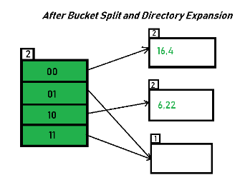
*Notice that the bucket which was underflow has remained untouched. But, since the number of directories has doubled, we now have 2 directories 01 and 11 pointing to the same bucket. This is because the local-depth of the bucket has remained 1. And, any bucket having a local depth less than the global depth is pointed-to by more than one directories.
- Inserting 24 and 10: 24(11000) and 10 (1010) can be hashed based on directories with id 00 and 10. Here, we encounter no overflow condition.
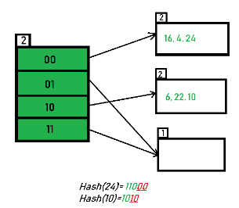
Inserting 31,7,9: All of these elements[ 31(11111), 7(111), 9(1001) ] have either 01 or 11 in their LSBs. Hence, they are mapped on the bucket pointed out by 01 and 11. We do not encounter any overflow condition here.
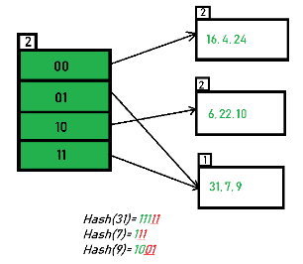
Inserting 20: Insertion of data element 20 (10100) will again cause the overflow problem.
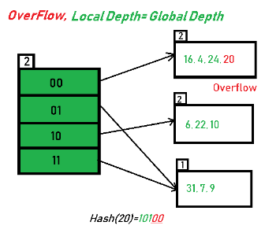

20 is inserted in bucket pointed out by 00. As directed by Step 7-Case 1, since the local depth of the bucket = global-depth, directory expansion (doubling) takes place along with bucket splitting. Elements present in overflowing bucket are rehashed with the new global depth. Now, the new Hash table looks like this:
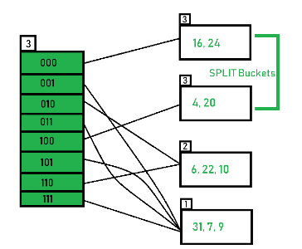
- Inserting 26: Global depth is 3. Hence, 3 LSBs of 26(11010) are considered. Therefore 26 best fits in the bucket pointed out by directory 010.
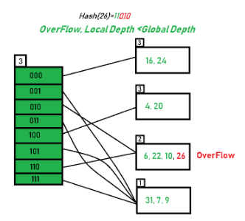
- The bucket overflows, and, as directed by Step 7-Case 2, since the local depth of bucket < Global depth (2<3), directories are not doubled but, only the bucket is split and elements are rehashed.
Finally, the output of hashing the given list of numbers is obtained.
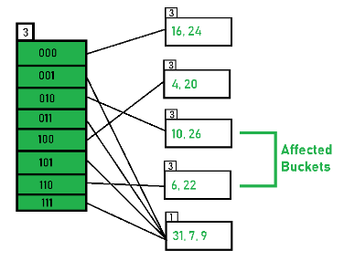
- Hashing of 11 Numbers is Thus Completed.
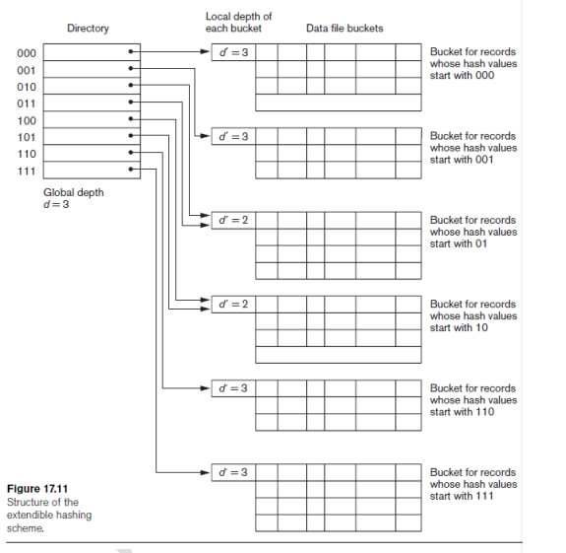

Indexes on Multiple Keys
The primary or secondary keys on which files were accessed were single attributes (fields). In many retrieval and update requests, multiple attributes are involved. If a certain combination of attributes is used frequently, it is advantageous to set up an access structure to provide efficient access by a key value that is a combination of those attributes.
For example, consider an EMPLOYEE file containing attributes Dno (department number), Age, Street, City, Zip_code, Salary and Skill_code, with the key of Ssn (Social Security number).
Consider the query: List the employees in department number 4 whose age is 59. Note that both Dno and Age are nonkey attributes, which means that a search value for either of these will point to multiple records. The following alternative search strategies may be considered:
1. Assuming Dno has an index, but Age does not, access the records having Dno = 4 using the index, and then select from among them those records that satisfy Age = 59.
2. Alternately, if Age is indexed but Dno is not, access the records having Age = 59 using the index, and then select from among them those records that satisfy Dno = 4.
3. If indexes have been created on both Dno and Age, both indexes may be used; each gives a set of records or a set of pointers (to blocks or records). An intersection of these sets of records or pointers yields those records or pointers that satisfy both conditions.

All of these alternatives eventually give the correct result. However, if the set of records that meet each condition (Dno = 4 or Age = 59) individually are large, yet only a few records satisfy the combined condition, then none of the above is an efficient technique for the given search request. A number of possibilities exist that would treat the combination < Dno, Age> or < Age,Dno> as a search key made up of multiple attributes.
